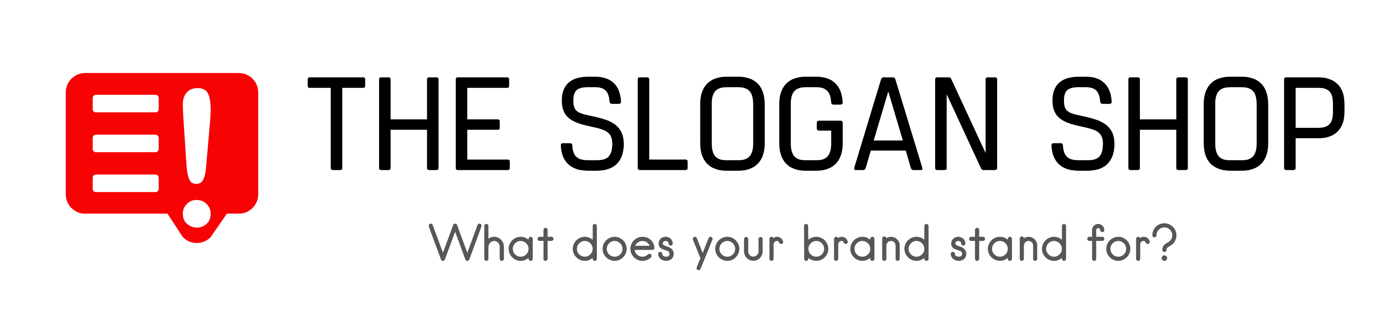

Logo Design Questionnaire

Note: upon completion, please send this document to us at info@thesloganshop.com. We’ll be in touch with lightning-fast speed to confirm receipt and begin work.

Designing a logo is all about the details. Please answer as many questions as you can:

The big picture

- What words or letters do you want included in your logo?

- Do you have a slogan/tagline? Do you want it to be included in the logo?

- Quick creative exercise: if your logo were a celebrity, who would it be and why?

- Provide five adjectives to describe your logo. Some examples are below:
(Feminine, Masculine, Young, Mature, Luxury, Economical, Modern, Classic, Playful, Serious, Loud, Quiet, Simple, Complex, Subtle, Obvious)

- - - - - - - - - - - - - - - - - - - - - - - - - - - - - - - - - - - - - - - - - - - - - - - - - - - - - - - - - - - - - - - - - - - -

Tell us about your company/target audience:

- Explain what your company / organization is and does.

- How are you different than your competition?

- What are the benefits of your product/service?

- What attributes of your business / organization would you like your logo to reflect?

- Who are you trying to attract with your marketing message? Be specific.

- What is the overall message you want to convey to your target audience?

- - - - - - - - - - - - - - - - - - - - - - - - - - - - - - - - - - - - - - - - - - - - - - - - - - - - - - - - - - - - - - - - - - - -

Describe what you want designed:

- Describe your aims and requirements in detail here — the more specific, the better. Tell the designers what is required, but also let them know where they’re free to be creative.

- What key pieces of information / copy need to be included?

- Include links to any images, sketches, or documents that may be helpful.

- - - - - - - - - - - - - - - - - - - - - - - - - - - - - - - - - - - - - - - - - - - - - - - - - - - - - - - - - - - - - - - - - - - -

Design preferences

- Use Google to search for similar designs that you like, include at least (3), explain why you like them and what to include/exclude in your design.

- Do the same exercise but look for (3) design styles that you DO NOT like and explain why.

- - - - - - - - - - - - - - - - - - - - - - - - - - - - - - - - - - - - - - - - - - - - - - - - - - - - - - - - - - - - - - - - - - - -

Tone & Image:
Funny / Casual / Formal / etc. What tone and imagery will be most effective, specific visual goals?

- - - - - - - - - - - - - - - - - - - - - - - - - - - - - - - - - - - - - - - - - - - - - - - - - - - - - - - - - - - - - - - - - - - -

What colors would you like to see in your logo? (It is usually best to stick to one or two colors):

- Red: Passion, Anger, Vigor, Love, Danger
- Yellow: Knowledge, Energy, Joy, Intellect, Youth
- Green: Fertility, Wealth, Healing, Success, Growth
- White: Purity, Healing, Perfection, Clean, Virtue
- Blue: Knowledge, Trust, Tranquility, Calm, Peace, Cool
- Black: Fear, Secrecy, Formal, Luxury
- Purple: Royalty, Wisdom, Spirituality, Imagination
- Orange: Creativity, Invigoration, Unique, Stimulation
- Gray: Balance, Sophistication, Neutrality, Uncommitted

- - - - - - - - - - - - - - - - - - - - - - - - - - - - - - - - - - - - - - - - - - - - - - - - - - - - - - - - - - - - - - - - - - -
Below you see different ‘genres’ of logos. Please select (write below, image can’t be clicked) the one that you feel best suits your needs/preferences.

Important note: our fee does not include custom character design or mascots. For these projects, an extra change of $150 will apply. Contact us at info@thesloganshop.com if this is what you require and we will send you a Paypal Merchant invoice for the total fee.
